

AI Contribution Declaration Form

Manuscript title: Iatrogenic Glans Penis Injury During Circumcision: Clinical Spectrum, Mechanisms, and Medicolegal Implications—A Systematic Review

Please indicate whether Artificial Intelligence (AI) tools or software were used in the preparation of your manuscript by checking the relevant boxes below:
Area of Contribution | AI Used | Description of Use (specify tool/software, e.g., ChatGPT, Grammarly, etc.)
1. Idea/Conceptualization of the Manuscript | - Yes ☒ No
2. Article Review / Literature Search / Summarization | - Yes ☒ No
3. Content Generation (drafting text, paragraphs, or sections) | - Yes ☒ No
4. Table and Figure Generation | - Yes ☒ No
5. English Language Editing / Grammar / Style | ☒ Yes ☐ No | ChatGPT (OpenAI): English-language editing, grammar

Author’s Declaration
I hereby declare that the information provided above is accurate and complete to the best of my knowledge. I understand that transparency in the use of AI tools is essential for research integrity.
During the preparation of this work, the author(s) used ChatGPT (OpenAI) for English-language editing, structural refinement, and revision of selected text to align with journal requirements. The author(s) subsequently reviewed and edited all content and take full responsibility for the published article's content.

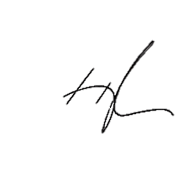
Name of Corresponding Author: Abdul Hakim Nitiprodjo

Signature: ____________________ Date: 08 September 2026

